Assignment 1

Title – Good Design (Internet)

1. Swiss Army Knife

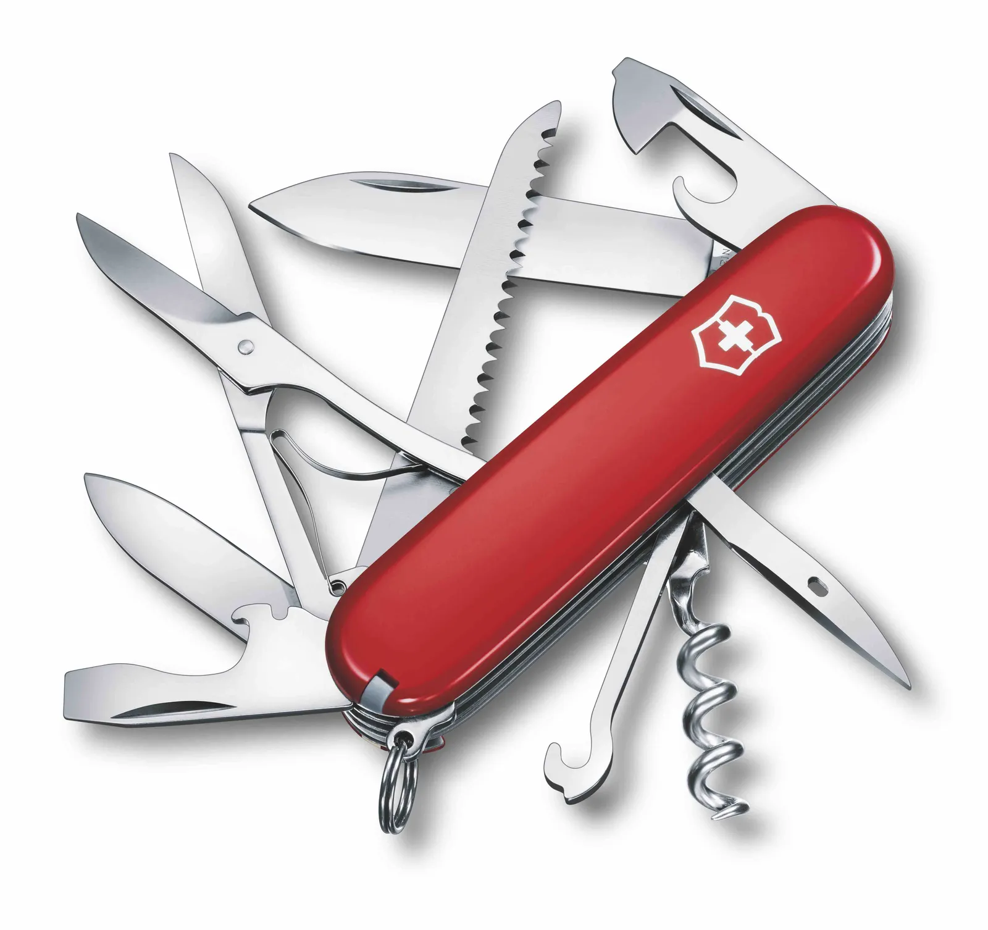
Source – Google Images

Why it is Good ?
This Kinfe consists of different points that can be used to perform different operations such as removing a cork, bottle opener, cutting, etc and also it is very small in size thus easy to fit in pocket.

2. Egg Yold Seperator

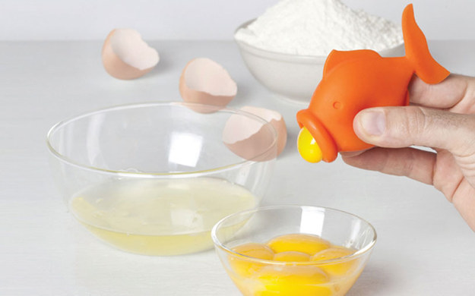

Source – Google Images

Why it is Good ?

Some people like to eat the egg white and egg yolk separate, like the people who go to GYM and have a strict diet, so they prefer to eat egg white instead of egg yolk thus egg yolk separater is used.

3. Candy Storage

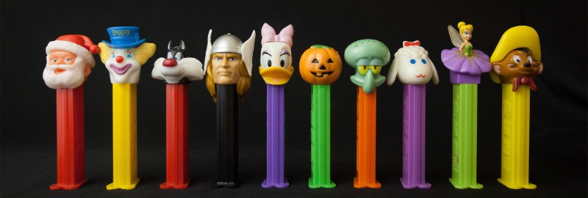

Source - www.manypixels.co

Why it is Good ?

The candy storage is used to store the candy when we want to eat it later, this prevents the candy from getting watery, sticky and also keeps them safe from ants.

4. Hold my Cable

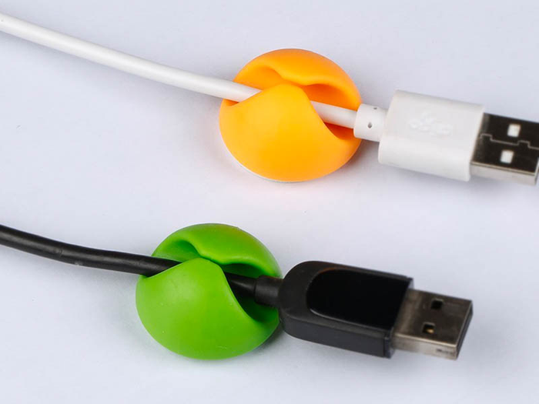

Source – Google Images

Why it is Good ?

The Cables when they are not in used are left hanging which can cause damage to them if the fall into water or gets stuck in a corner, so the cable holder can be used to hold the cable when it is not in used or it can also be used to fix the cable in one place for cable management.

5. Safety First, Nail Later.

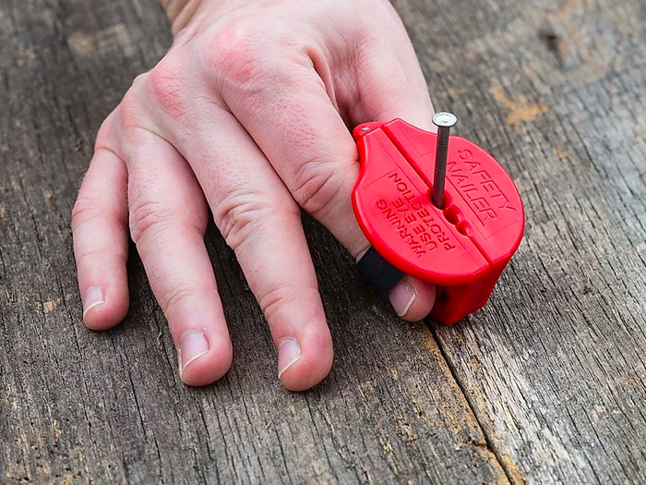

Source – Google Images

Why it is Good ?

The nail holder can be used to hold the nail while hammering so when a person is not sure of his hammering skills he can use the holder to keep his fingers safe.

